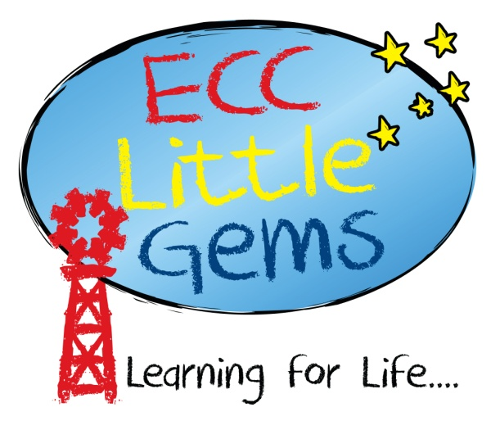

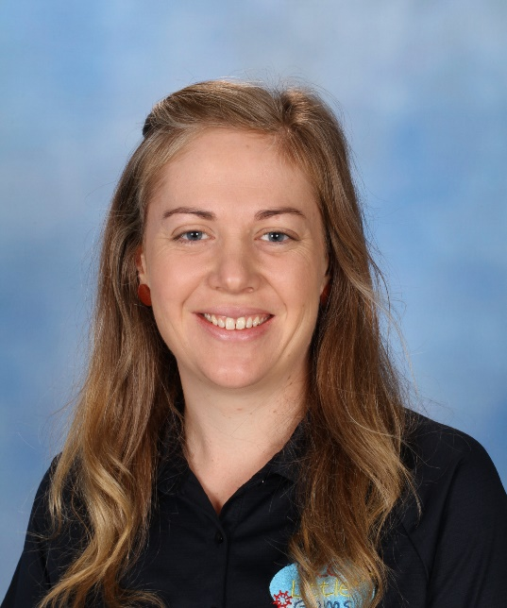

**Zoe Sefton**

**Educational Assistant - Kindergarten**

My name is Zoe Sefton and I have been part of the Little Gems team since April 2021 where I am the kindergarten assistant in both Sapphire and Garnet Kindy groups. I was born and raised in Emerald and proudly call it home with my Husband Tim and our 5 children. I value family time and enjoy getting out camping and the outdoors.

 Having had the privilege to be a stay at home Mum for the last 10 years, God led me into the childcare industry where I have welcomed the new challenges and excitement that comes with the role. I am currently studying for my Diploma in Early Childhood education and enjoy seeing all the children learn and grow in their own unique way.

It is a great privilege to see every child’s individual gifting and strengths that God has given them and a great joy to help them in their journey. I look forward to seeing your little ones flourish in their very exciting year of kindy.