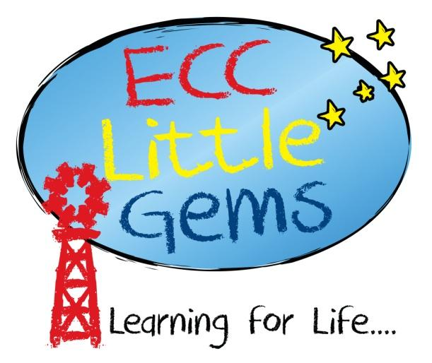

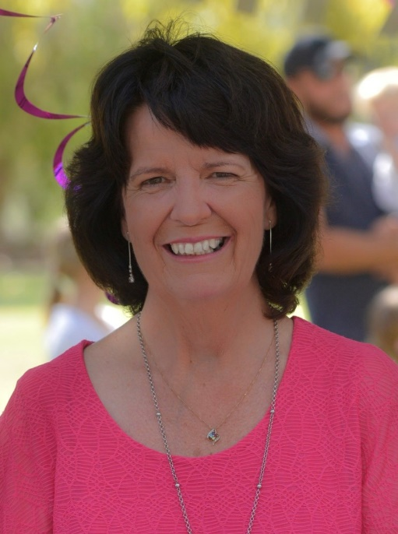

Lorraine Grierson
Kindergarten Teacher

Hello my name is Mrs Lorraine Grierson. I am married to Ross and have 4 adult sons, 2 daughters in law and 5 beautiful grandchildren. We have lived in Emerald for 21 years. I was the founding principal of the Emerald Christian College and worked in that capacity for 10 years, followed by 10 years as Head of Primary where I was part of the team who worked to open our “Little Gems” centre. I hold both a general Bachelor of Education and one in Early Childhood Studies.

God has given me a passion to see children develop a love for learning and to carefully help them to navigate this time of their lives. I bring to the team nearly 30 years of experience in education and I love working together with highly motivated dedicated educators who strive to see each child achieve great things.

It is a real blessing to me to be joining the “Little Gems” team.

