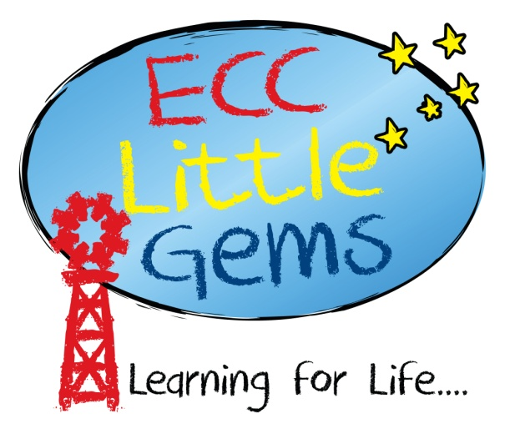

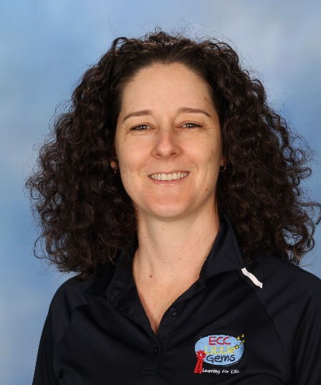

My name is Engelie Nel and I’ve been a part of ECC since 2010 where I started my journey in Australia as the Prep teacher. In our spare time, my three children and I love spending time going camping, especially near the beach.

My family and I are originally from South Africa, where I completed my studies to become a teacher in Early Childhood Education in 2001. I gained experience in teaching English as a second language in Taiwan for 3 and a half years before coming over to Australia.

After working at ECC as the Prep teacher for 7 years, I moved across to Little Gems in 2017 to become the Kindergarten Teacher and was appointed as the Director in 2020. My passion is to help children to grow in their independence and getting to know who God created them to be. I strive to create an environment where children can grow and develop at their own pace and where families will feel safe and supported in their journey of parenting and guiding their children.

**Engelie Nel**

**Kindergarten Teacher**